Catering Information Form

Welcome to CaterTrax. We look forward to working with you to customize your CaterTrax site. To prepare for our information gathering call, please read through the information and questions and have the information we need handy.

During our call we’ll discuss some additional options based on your business, as well as expectations for the timing of your site launch. The call will also give you an opportunity to ask any questions you may have. In addition to the questions below, we’ll cover the following topics:

- Delivery and pick up options
- Order fulfillment lead time requirements
- Day of week / date management
- Specific information required for billing methods (Cost Center number, Department Name, etc.)
- Order approval requirements and capabilities (if applicable)
- Optional field labels and display messages
- Any additional / special requirements for your location

- How should your business name appear on the site? How do you refer to your business to your customers? Note: This will appear on your home page along with address and telephone information, and also on your invoices. Examples -­‐ XYZ Catering, XYZ Catering at
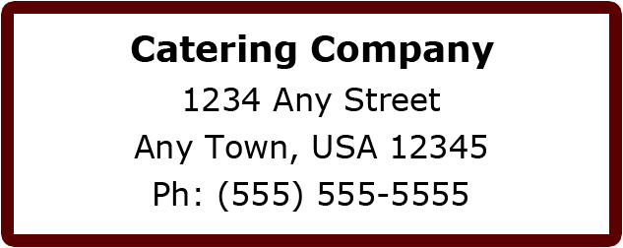

- What phone number should be posted for Catering Office contact?

- Have you received and returned the site info questionnaire?

- Have you submitted your Catering menu with current pricing and item descriptions yet?

- How recently has your menu been updated?

- Is your menu content and pricing complete and finalized with no major changes anticipated in the near future?

- Do you have more than one catering menu? If so, please specify.

- Who is the primary person regarding menu questions?

- What email address (es) should be used for notification of newly placed orders?
We recommend listing addresses for more than one person, considering vacations, illness, etc.

- What are your catering service hours Monday through Friday?
These are the earliest and latest service times available for your customers to select, such as 6:00 am – 7:00 pm, etc.

- What are your catering service hours for weekends?
These are the earliest and latest service times available for your customers to select, such as 6:00 am – 7:00 pm, etc.

- The TRAX Platform allows you to ask your customer for a minimum of two to a maximum of four time fields for each order. These times can be labeled as you wish, but commonly used examples are, Food Delivery Time, Event Start Time, Event End Time, and Food Clean up Time. We can further explain your options and system requirements during our call.

- Is there a minimum dollar value required for delivery orders?

- Do your customers often book more than one order for a day’s events, such as breakfast, morning break, and lunch?

- Do you charge sales tax? If so, what is the rate? Will you offer an option for tax exempt status? Any additional tax rules can be discussed on the call.

- Please list any service ware options such as disposable, china, premium disposable, etc., and identify any associated fees.

- Do you charge a delivery fee? If so, please describe and let us know if these fees are taxable?

- Do you have an administrative fee or any other fee that will automatically apply to orders? If so, are these fees taxable?

- Do you charge a rush order fee? If so, please describe and let us know if this fee is taxable?

- What forms of payment will you accept for catering orders?
Please provide a detailed description of the payment types that you wish to offer. For each payment type also list any additional information needed. For example: If you allow a customer to pay by Cost Center, then you would need to have a field for Cost Center Number. We will discuss optional functionality during the integration meeting.
Cash
Business Check
Cost Center
Credit Cards
Purchase Order
Other
Please provide any additional notes regarding forms of payment:

- Will any orders require a form of approval? If so, we can discuss options, requirements, and specific information during the telephone meeting.

- Have you submitted your catering policies to us?

- Do you want to require your customers to accept your policies by entering their initials at a prompt within the ordering process every time they order, one time at account registration, or not at all?

- What information would you like to have your customers fill in when registering as a new user?
Name, Phone Number, Password, and Email are all required. Please specify any additional fields that you feel should be required or requested for a one-time customer registration. Some commonly used examples are Address, Department, and Mobile Phone.

- Have you submitted your school/corporate logo?
This should be submitted in an image file. Logos may be displayed on your home page and on invoices generated by your CaterTrax system.

- Do you require a different logo (different from the logo on the home page) for your invoices?
If possible, we prefer your logo in a .jpg format. Logos can be displayed on your home page and on invoices generated by your TRAX Platform.

- What internal email system do your customers use?
Such as Outlook, Lotus Notes, etc.

Thank you for taking your time to complete this form. When complete, you may return this to us by email at Site.Launch@CaterTrax.com .

Site Information
Site Name:
CaterTrax Site URL (if known):

Your Name:

